

Project Name: Tours and Travels

Branch PG-DAC Mar-2023

Documentation On

**“Adventurous Tours & Travels”**

PG-DAC SEPT 2023

**Guided By: Snehal Somvanshi**

Submitted By :

**Group No: 11**

* **Akansha Suryawanshi 230343020093**
* **Pankaj Suryawanshi 230343020094**
* **Omkar Wandhare 230343020112**
* **Zubair Solanki 230343020115**

**Table of Contents**

**1. Introduction 4**

1.1 Document Purpose **4**

1.2 Project Background **4**

1.3 Aim & Objectives **4**

**2. Business Requirements Overview**…………………………………………………………**5**

**3.Functional Requirements** **6**

3.1 Tourist Module **6**

3.2 Guide Module **6**

3.3 Admin Module **7**

**4.** **Non-Functional Requirement………………………………………………………………7**

**5. Use Case Diagram**

5.1 Admin 8

5.2 Guide **9**

5.3 Tourist **10**

**6. Database Design 11**

1 User **11**

2 Admin **11**

3 Customer…………………………………………………………………………………11

4 Event **12**

5 Guide **12**

6 OrderDetails **13**

7 Order **13**

8 Payment **13**

**7. E-R Diagram………………………………………………………………………………………14**

**8. Snapshots 15**

**9. Project Architecture ………………………………………………………………………………..22**

**9. Conclusion 23**

**List of Figures**

**Use Case Diagrams 17**

Fig 1 Admin 8

Fig 2 Guide 9

Fig 3 Tourist 10

Fig 4 ER Diagram 14

1. **Introduction:**
   1. **Document Purpose:**

This document communicates the business requirements and scope for developing

Tours and Travels. The scope of this document is to define the functional and non functional requirements, business rules and other constraints requirements.

## Project Background:

Online Tour Booking System is a valuable tool for customers who want to easily plan and book their travel arrangements online. The system offers a convenient and user-friendly interface that allows customers to browse and make bookings. As offline tour booking and

searching good packages is very tedious job so by keeping this challenge in mind, we decided to work on a system where we can provide a facility for searching tours and booking online by very simple process. By using this system any tourist who is living at remote area can easily book a tour.

## Aim & Objectives:

The main objective of this system is building a website which improves user accessibility and time flexibility to plan a tour no matter where they are located. Basically we are providing features like searching packages with images, searching by location booking tours. The key benefits of online booking are low cost tours as compared to offline tours. Tourists can book tour within minutes from anywhere from country.

1. **Business Requirements Overview:**

* Tours and Travels is a website for planning and booking tours.
* Tours and Travels is opened to the global, but in phase 1, the main target is a tourists from India.
* There are mainly two types of user. One is the Tourists and other is Guide.
* Tourists can go through planned tours, images, see tours details like locations, duration etc.
* Assigning Tour guide to respective tour group.
* Guide can plan new tours and add to the package details with the approval of admin.
* Tours and Travels is maintained by Administrator.

Tours and Travels provides such functionalities through which tourists can book tour and enjoy their adventure holidays happily.

# Functional Requirements Overview:

Tour Management System consists of three modules described as below.

1. Tourist Module
2. Guide Module
3. Admin Module

# **3.1 Tourist** **Module**

* Tourists will able to see the existing packages and details.
* Tourists will have login first before booking the tour.
* Tours and Travels provides the functionalities like searching the packages by searching by date, location.
* Tourists can see the invoice after booking the tour.

# **Guide Module**

* Tours and Travels provides the functionality which allows Guide to add new tour packages.
* Tours and Travels provides the functionality by which Guide can plan tours.
* Tours and Travels provides the functionality by which guide can modify and delete

the packages which where added.

# **3.3 Admin Module**

* Tours and Travels provide a functionality by which admin can add new Guide to the system.
* Tours and Travels provide a functionality by which admin can view customer details, tour guide details and orders details of customers.

1. **Non-Functional Requirement:**

* The website should use professional design, look and feel and color scheme.
* Users will have no limitations for accessing the application through Internet.
* Being a public website, the site must follow general usability guidelines for menus, navigation, colors, links and other actions provided on the screens.
* The system should be designed in such a manner that user will be able to complete tasks in minimum number of steps.

.

## 5. Use-Case Diagram

**5.1 Admin:**

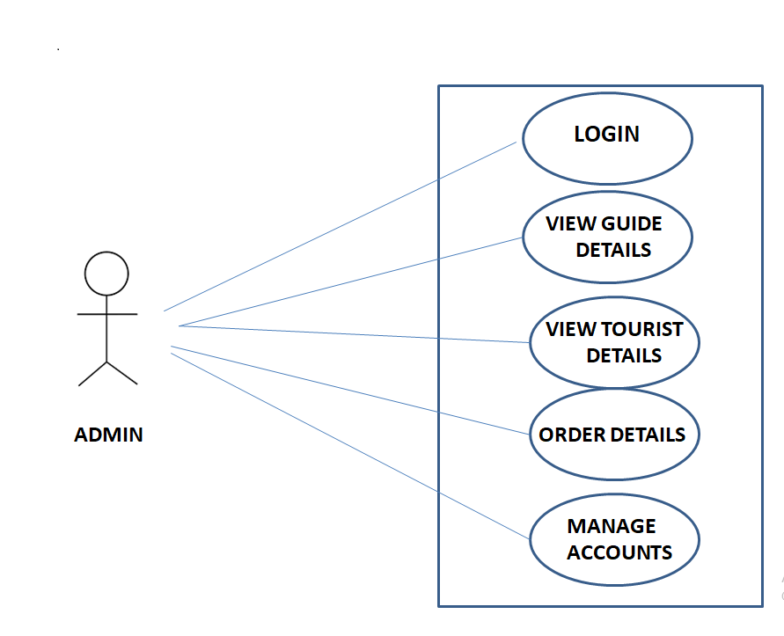

Fig. Use-Case Diagram for Admin

## 5.2 Tourist:

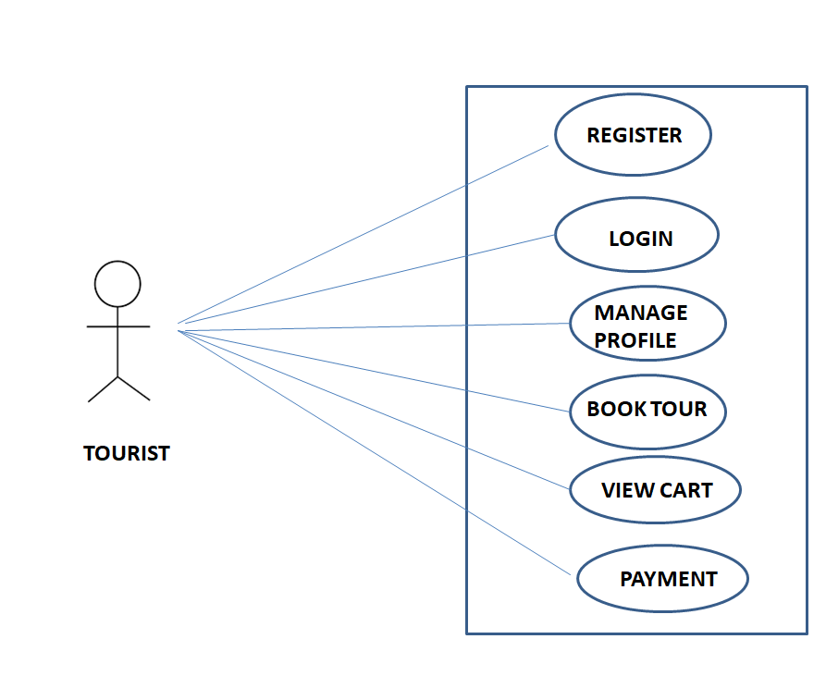

Fig. Use-Case Diagram for Tourist

**5.3 Guide:**  
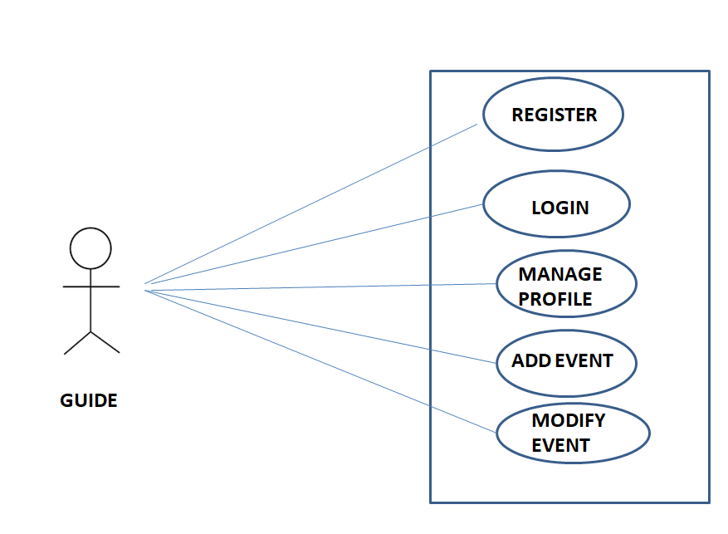

Fig. Use-Case Diagram for Guide

* **Database Design:**

**1] Tbl_User**

|  |  |  |  |  |  |
| --- | --- | --- | --- | --- | --- |
| **Field** | **Type** | **Null** | **Key** | **Default** | **Description** |
| Id | Integer | No | Primary key | Null | User Id |
| City | Varchar(255) | No |  | Null | City |
| Country | Varchar(255) | No |  | Null | Country |
| State | Varchar(255) | No |  | Null | State |
| Zip | Varchar(255) | No |  | Null | Zip |

**2] Tbl_Admin**

|  |  |  |  |  |  |
| --- | --- | --- | --- | --- | --- |
| **Field** | **Type** | **Null** | **Key** | **Default** | **Description** |
| UserId | Varchar(255) | No | Primary key | Null | ID |
| Password | Varchar(255) | No |  | Null | Password |
| Uname | Varchar(255) | No |  | Null | User Name |

**3] Tbl_Customer**

|  |  |  |  |  |  |
| --- | --- | --- | --- | --- | --- |
| **Field** | **Type** | **Null** | **Key** | **Default** | **Description** |
| Id | Integer | No | Primary key | Null | Customer ID |
| City | Varchar(255) | No |  | Null | City |
| CreatedTimestamp | DateTime | No |  | Null | Created Timestamp |
| Gender | Varchar(255) | No |  | Null | Gender of customer |
| Name | Varchar(255) | No |  | Null | Name of customer |
| Phone | Varchar(255) | No |  | Null | Phone no. of customer |
| PWD | Varchar(255) | No |  | Null | Paasword |

**4] Tbl_Event**

|  |  |  |  |  |  |
| --- | --- | --- | --- | --- | --- |
| **Field** | **Type** | **Null** | **Key** | **Default** | **Description** |
| EventId | Integer | No | Primary key | Null | Event ID |
| CreatedTimestamp | DateTime | No |  | Null | Created Timestamp |
| Dailywiseschedule | VARCHAR(4000) | No |  | Null | Dailywiseschedule |
| Date | DateTime | No |  | Null | Date |
| Description | VARCHAR(4000) | No |  | Null | Description |
| Eventcat | VARCHAR(255) | No |  | Null | Event Category |
| Eventname | VARCHAR(255) | No |  | Null | Event Name |
| Location | VARCHAR(255) | No |  | Null | Location |
| Noofdays | VARCHAR(255) | No |  | Null | No of Days |
| Photo1 | VARCHAR(255) | No |  | Null | Photo 1 |
| Photo2 | VARCHAR(255) | No |  | Null | Photo 2 |
| Photo3 | VARCHAR(255) | No |  | Null | Photo 3 |
| PickUpAndDropLocation | VARCHAR(255) | No |  | Null | Pick up and drop location |
| Price | INTEGER | No |  | Null | Price |
| ThingsToCarry | VARCHAR(4000) | No |  | Null | Things to carry |
| Guided | INTEGER | No |  | Null | Guide |

**5] Tbl_Guide**

|  |  |  |  |  |  |
| --- | --- | --- | --- | --- | --- |
| **Field** | **Type** | **Null** | **Key** | **Default** | **Description** |
| Id | INTEGER | No | Primary key | Null | Guide Id |
| City | VARCHAR(255) | No |  | Null | City |
| CreatedTimestamp | DATETIME | No |  | Null | Created Timestamp |
| Name | VARCHAR(255) | No |  | Null | Guide name |
| Phone | VARCHAR(255) | No |  | Null | Phone no |
| PWD | VARCHAR(255) | No |  | Null | Password |
| Email | VARCHAR(255) | No |  | Null | Email of guide |

**6] Tbl_Orderdetails**

|  |  |  |  |  |  |
| --- | --- | --- | --- | --- | --- |
| **Field** | **Type** | **Null** | **Key** | **Default** | **Description** |
| Id | Integer | No | Primary key | Null | Oreder Details ID |
| Quantity | Integer | No |  | Null | Quantity |
| EventId | Integer | No | Foreign Key | Null | Refernce to OrderDetails(Tbl_Event) |
| OrderId | Integer | No | Foreign Key | Null | Refernce to OrderDetails(Tbl_Order) |

**7] Tbl_Orders**

|  |  |  |  |  |  |
| --- | --- | --- | --- | --- | --- |
| **Field** | **Type** | **Null** | **Key** | **Default** | **Description** |
| OrderId | Integer | No | Primary key | Null | OrederID |
| OrderDate | DateTime | No |  | Null | Order Date |
| AddressId | Integer | No | Foreign Key | Null | Reference to Orders(Tbl_Address) |
| CustomerId | Integer | No | Foreign Key | Null | Reference to Orders(Tbl_Customer) |
| PaymentId | Integer | No | Foreign Key | Null | Reference to Orders(Tbl_Payments) |

**8] Tbl_Payments**

|  |  |  |  |  |  |
| --- | --- | --- | --- | --- | --- |
| **Field** | **Type** | **Null** | **Key** | **Default** | **Description** |
| Id | Integer | No | Primary key | Null | Payments ID |
| Amount | Integer | No |  | Null | Amount |
| CardNo | VARCHAR(255) | No |  | Null | Card No |
| NameOnCard | VARCHAR(255) | No |  | Null | Name of user on card |
| PaymentDate | DateTime | No |  | Null | Payment Date |

## ER-Diagram:

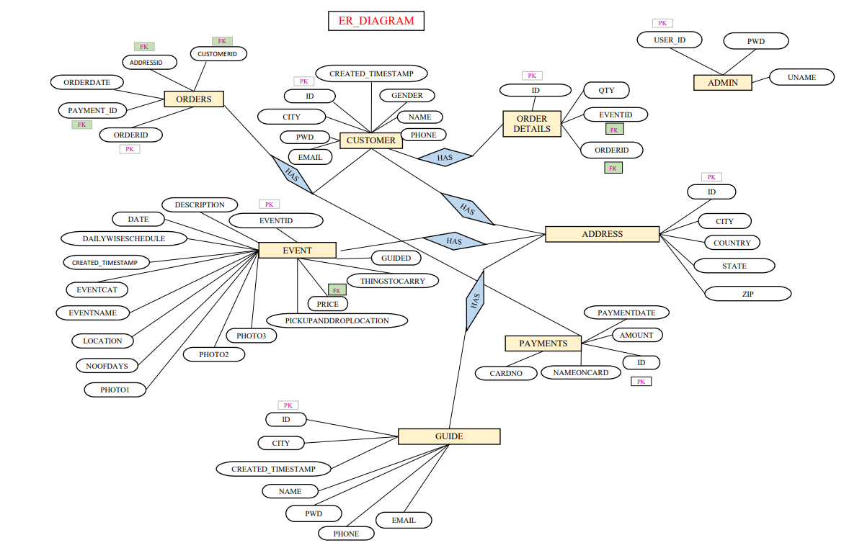

**E-R diagram shows database of Tours and Travels**

**8. Snapshots:**

**8.1 Home Page:**

Following snapshot shows the Home page for Tours and Travels before Login.

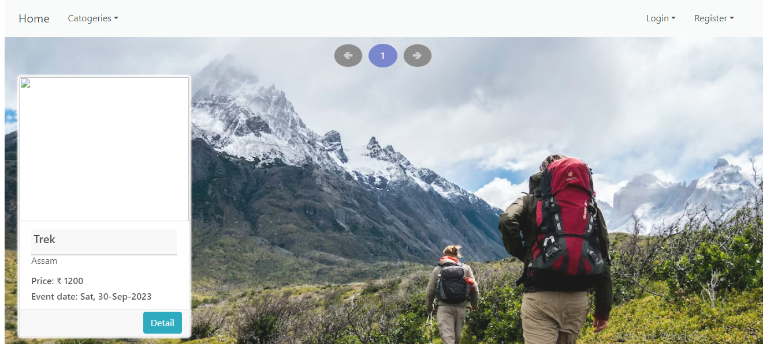

This page contains following controls

* Home
* Register
* Login Button

This page also contains footer consisting information about the website and contact us details.

**8.2 Admin Home Page**

**8.2 Login Page**

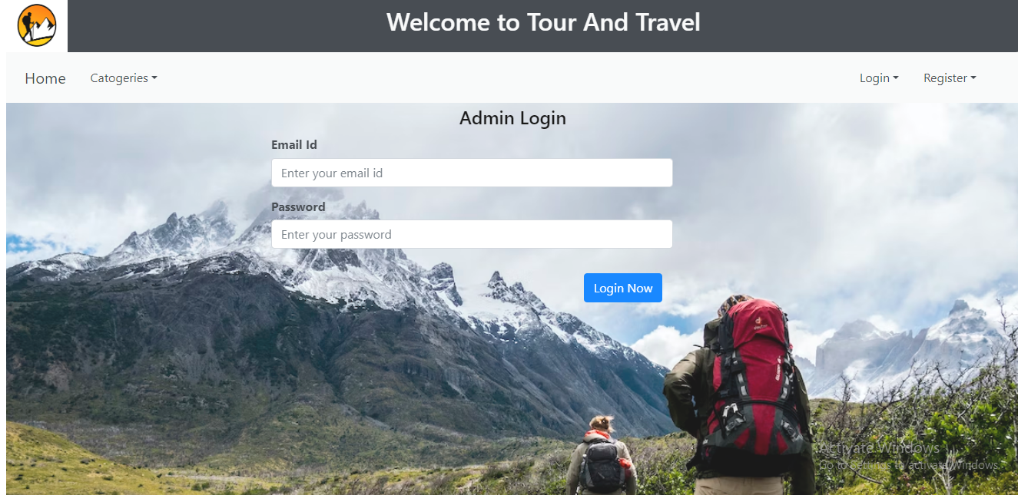

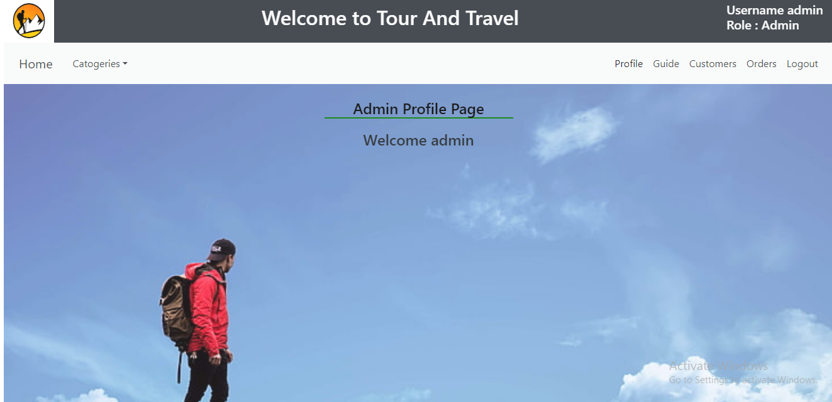

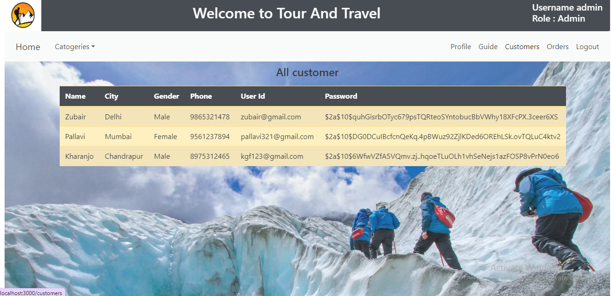

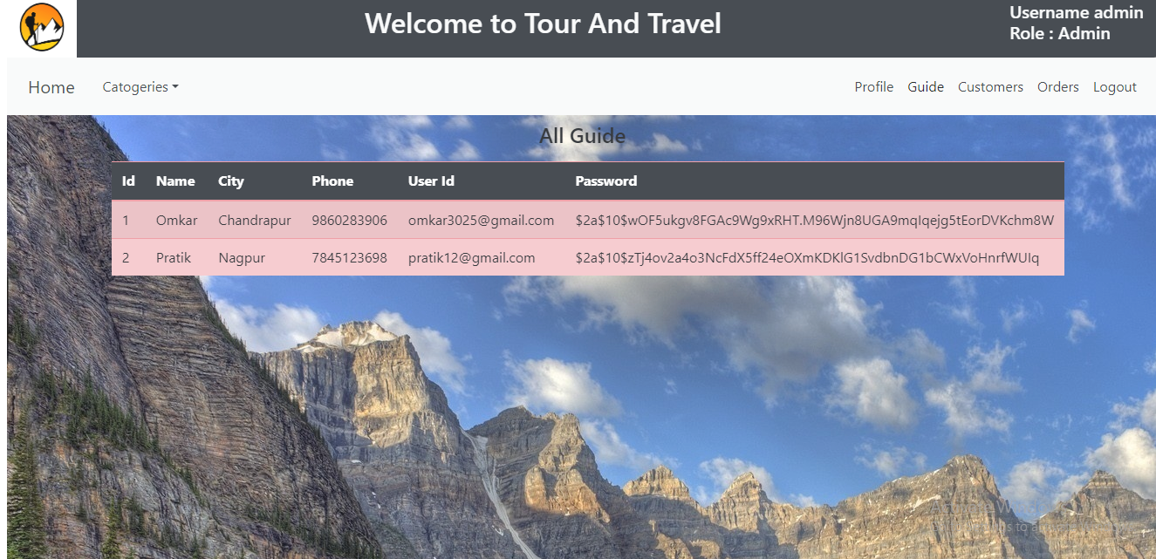

**8.5 Guide Page**

**8.4.1 Guide Page**

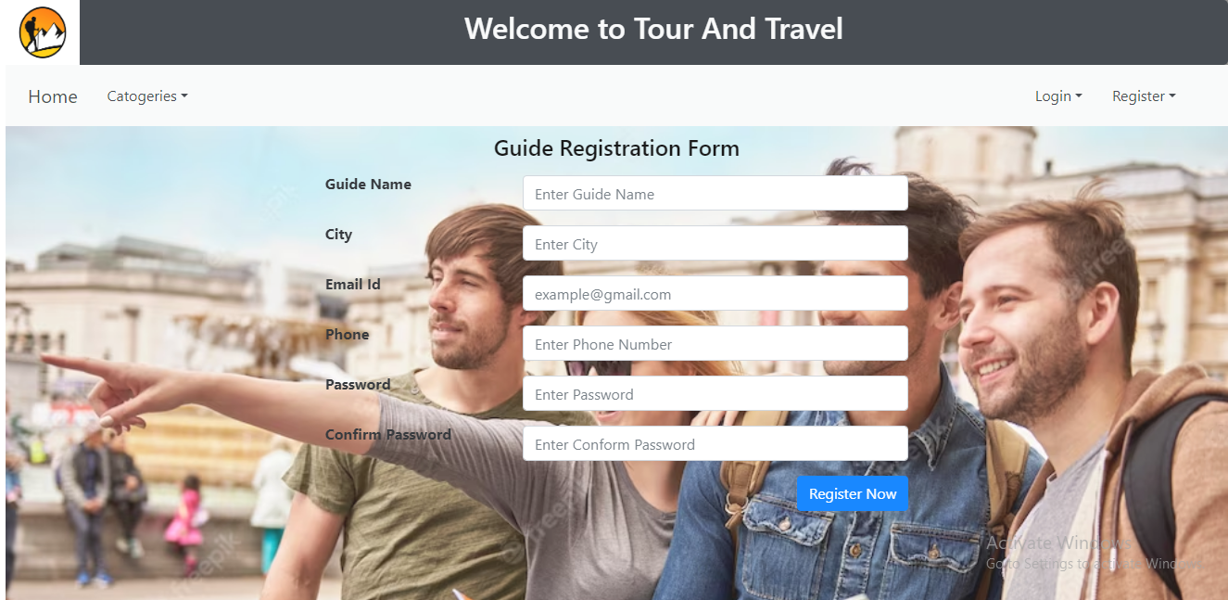

**8.4.2 Guide Add Event**

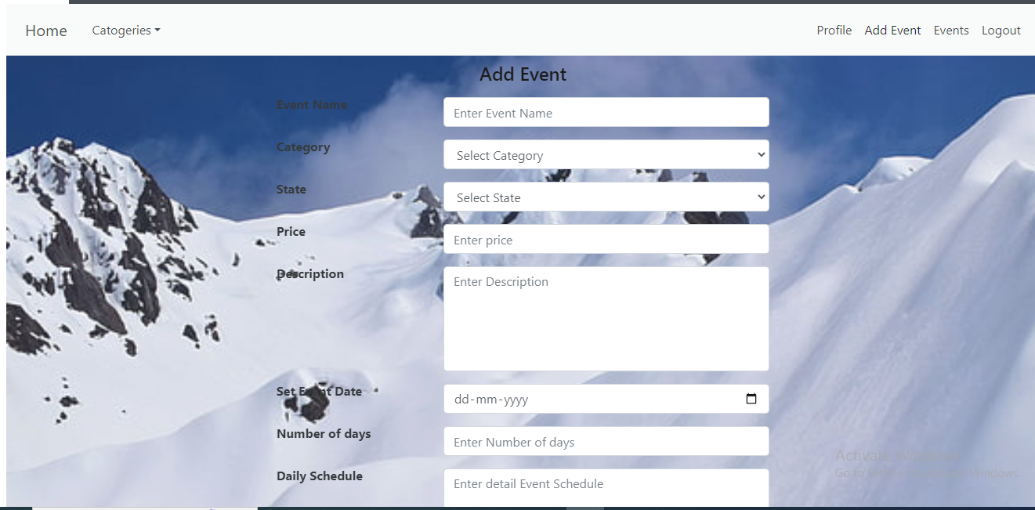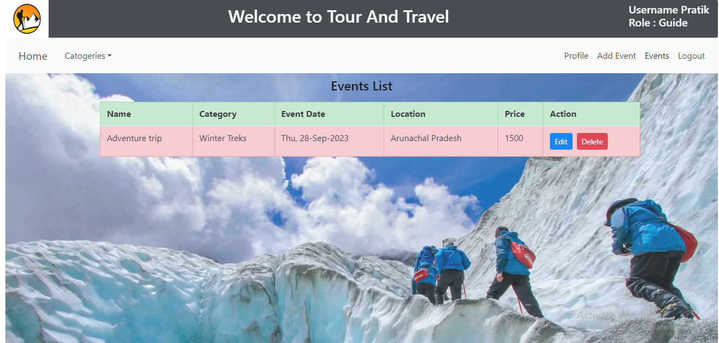

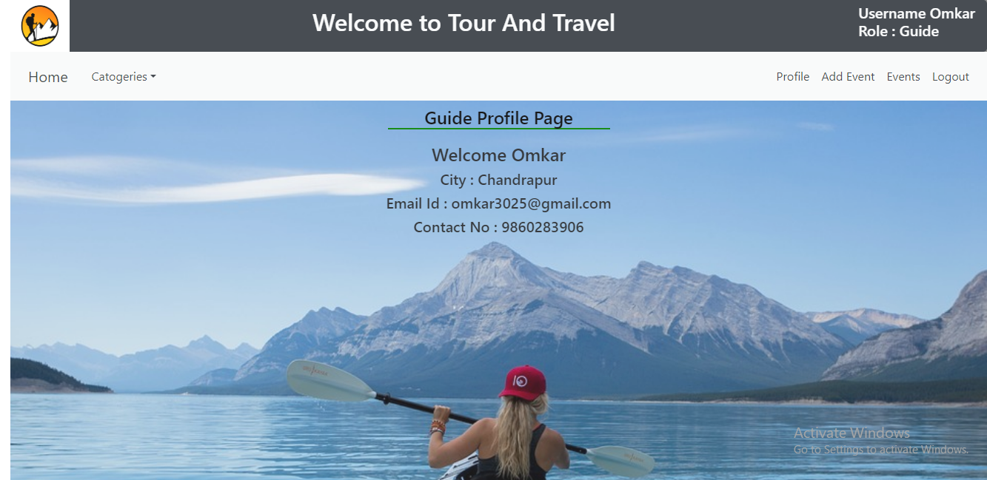

**8.6 Tourist Page**

**8.6.1 Tourist Registration**

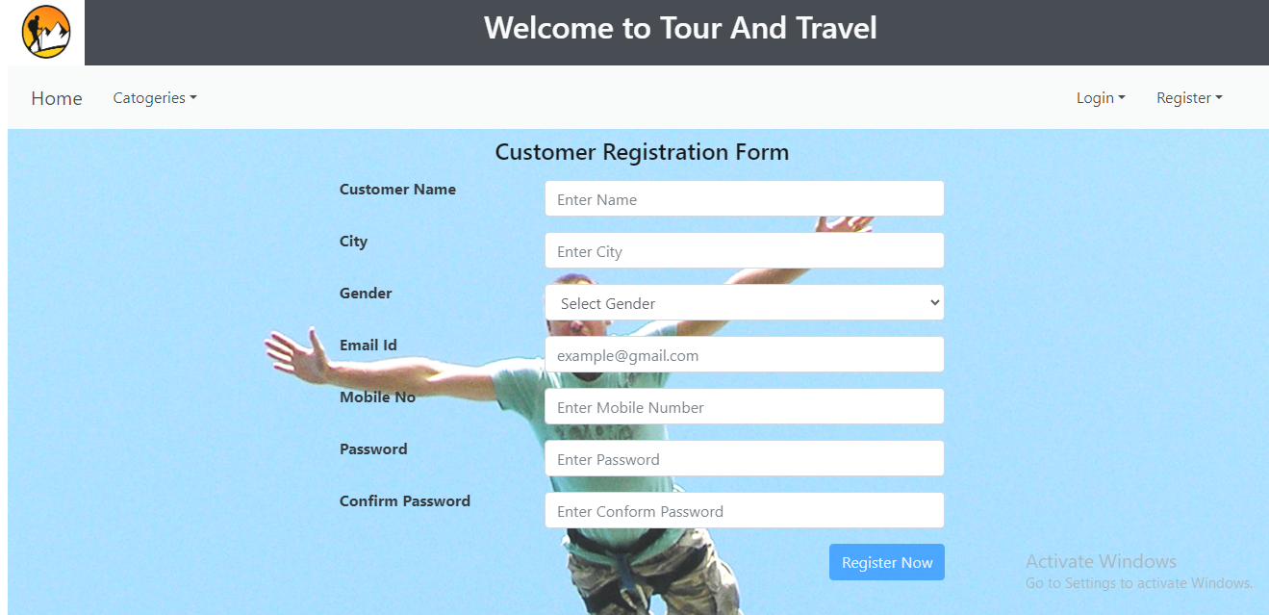

**8.6.2**

**View Events:**

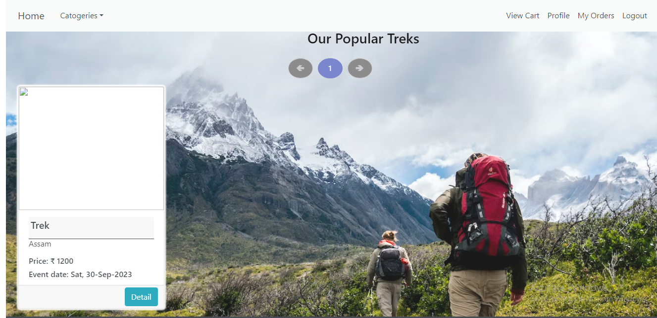

**View events and details accordingly**

**8.6.4 Event Booking**

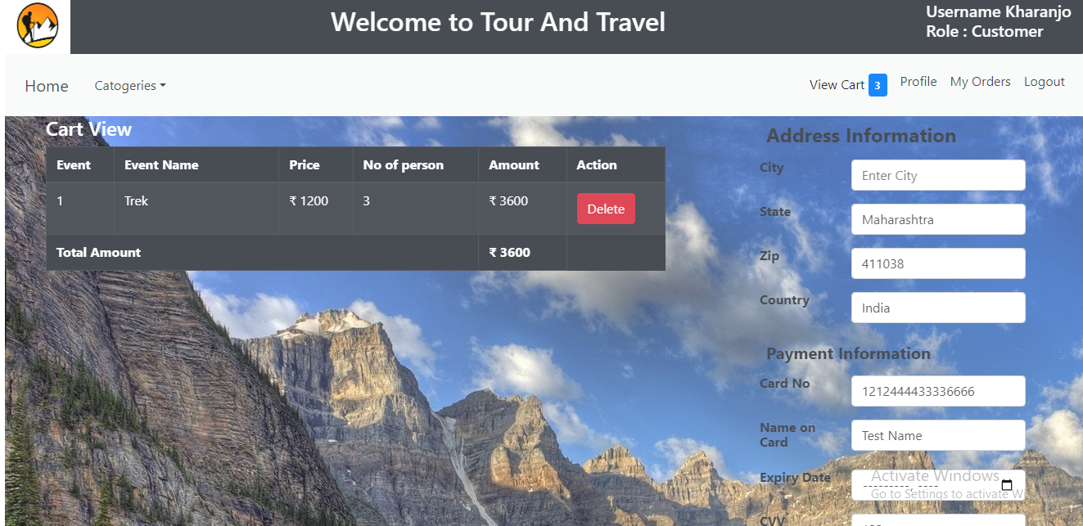

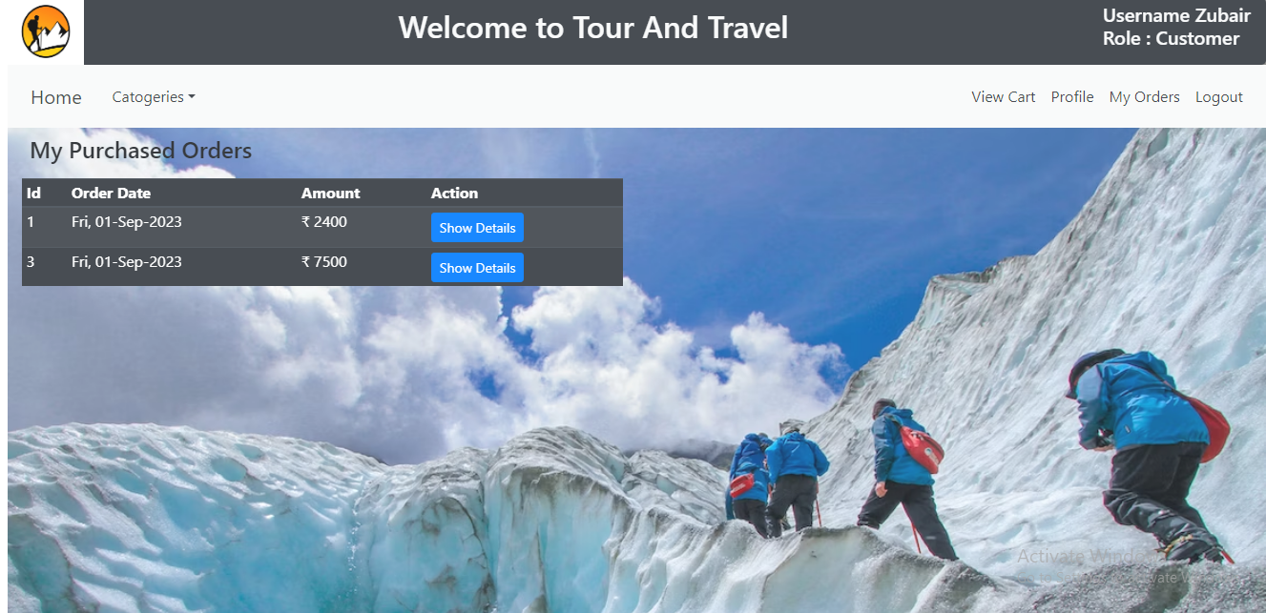

**9. CONCLUSION AND FUTURE SCOPE**

Tours and Travels provides better tour booking platform to book tours easily, economically and quickly.

Our System provides a very user-friendly platform where Tourists can easily book tours with the help of images according to their date and location given by tourists.

Our system will also provide functionalities like search by particular category, making travel arrangements, providing accommodation and tourists will also be able to customize their packages according to their need.

Two way verification will also provide security during registration.

Login credential will be received after tourist registration on email.

Tourists can get new password by using forgot password option directly on email.